Theme
Agentic AI that works in the real world: built, governed and trusted
NexGen Agentic AI Summit
London 2027
Businesses are racing to put AI agents to work, from banks in the City to hospitals, retailers and public services. But a working demo is not a dependable system. This summit is about the hard part: getting autonomous AI past the pilot stage while meeting UK regulatory expectations, protecting customer data and proving real returns.
Buttons: Become a Sponsor | Register as Delegate | Request Agenda
Summit theme
Taking agentic AI from promise to production, the UK way
Conference Date: 3rd June 2027
Conference Time: 09:00 HRS BST
Location: London, United Kingdom
Speakers: [25+] Expert Speakers
In-person event: London Edition

About The Event
The NexGen Agentic AI Summit, London Edition, is a one-day, in-person gathering for the people responsible for making AI agents work inside UK organisations. It covers the full journey, from choosing the right use case to running agents safely at scale.
Strategy | Engineering | Regulation | Results
AI agents no longer just draft text or answer questions. They book, approve, reconcile, escalate and decide. That shift raises questions that boards, regulators and customers are all asking: Who is accountable when an agent gets it wrong? How do we show the FCA, ICO or our own auditors what the agent did and why? And does it actually pay for itself?
London is where many of these questions are being answered first. The UK combines a world-leading financial services sector, a large public-sector estate, a strong AI research base and a regulatory approach that favours principles and accountability over rigid rules. Organisations trading into Europe must also reckon with the EU AI Act.
This summit brings leaders together to share what has worked, what has failed and what it really took to get there. Expect frank case studies, technical deep dives and practical frameworks you can take back to your team on Monday morning.

- [25+] Speakers
- [300+] Delegates
- [20+] Sessions
- [8+] Sponsors

Why Attend?
Learn how UK organisations are making agentic AI stick
- Real UK case studies: Hear from organisations across banking, insurance, healthcare, retail and government on what they deployed, what broke and what they would do differently.
- Regulation without the fog: Understand what expectations from the FCA, PRA, ICO and sector regulators mean in practice for autonomous systems, alongside UK GDPR and the EU AI Act for firms operating across borders.
- Build it properly: Get hands-on insight into agent architecture, orchestration, testing and monitoring from engineers who run these systems in production.
- Know your numbers: Learn how teams measure value, control running costs and build business cases that survive scrutiny from the finance director.
- Security and trust: Explore how to give agents safe access to systems and data, and how to contain the damage when something goes wrong.
- People and change: Find out how to bring staff, unions, customers and boards along as roles and workflows change.
- Vendor clarity: Meet platform and tool providers and compare approaches without the sales fog.
- Network with the right people: Spend a full day with senior leaders facing the same problems as you, with lunch, roundtables and an evening reception to continue the conversation.
Button: Count Me In!

Who Should Attend?
Designed for leaders and practitioners in AI, technology, risk and operations across UK enterprises and public bodies, including CTOs, CIOs, CAIOs, CISOs, Chief Data Officers, Directors, Heads and senior specialists in:
- AI & Machine Learning
- Agentic AI & Automation
- Enterprise & Solution Architecture
- Platform Engineering & DevOps
- Data & Analytics
- Digital Transformation
- Cyber Security & Information Security
- Risk, Compliance & Legal
- Operations & Customer Service
- Procurement & Vendor Management
- Public Sector Innovation
- Others

Industries
- Banking & Financial Services
- Insurance & Lloyd's Market
- Healthcare, NHS & Life Sciences
- Public Sector & Government
- Retail & Consumer Goods
- Telecoms & Media
- Energy & Utilities
- Manufacturing & Logistics
- Legal & Professional Services
- Technology & Software

Topics We Cover
- Beyond the Chatbot: What Agentic AI Really Changes for UK Business
- Choosing Use Cases That Deserve an Agent (and Those That Don't)
- Designing the Agent Stack: Build, Buy or Blend
- Making Agents Work Alongside Legacy Systems
- Orchestrating Many Agents Without Losing Control
- Who Is Accountable? Governance, Senior Manager Responsibility and Board Oversight
- Complying in Practice: UK GDPR, FCA and PRA Expectations, and the EU AI Act
- Giving Agents the Right Access: Identity, Permissions and Data Security
- Testing and Monitoring: Catching Failures Before Customers Do
- The Real Cost of Running Agents at Scale
- Proving the Return: Metrics Your CFO Will Accept
- Agentic AI in Financial Services, Healthcare and the Public Sector
- Workforce, Skills and Change: Preparing People for AI Colleagues
- Responsible and Trustworthy AI: Fairness, Transparency and Customer Trust
Get the full agenda | Button: Request Agenda

Speakers

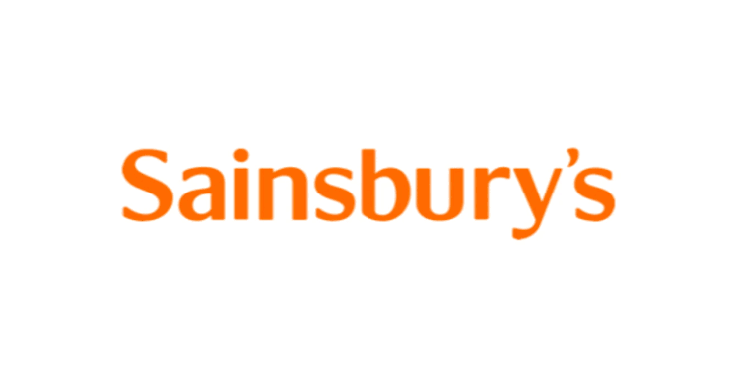
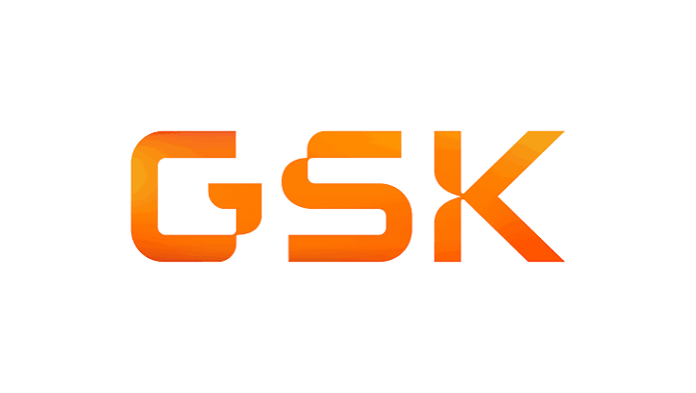
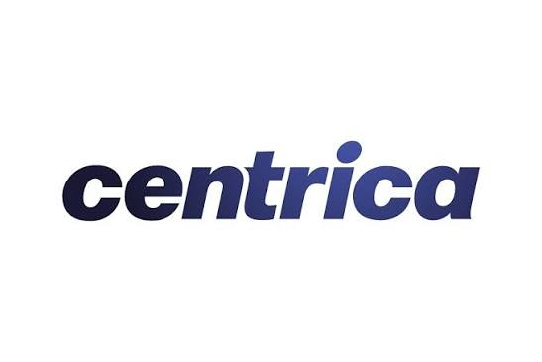


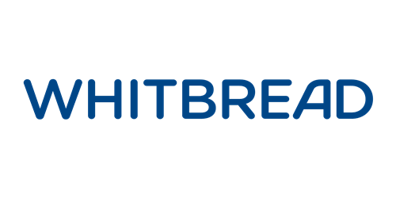
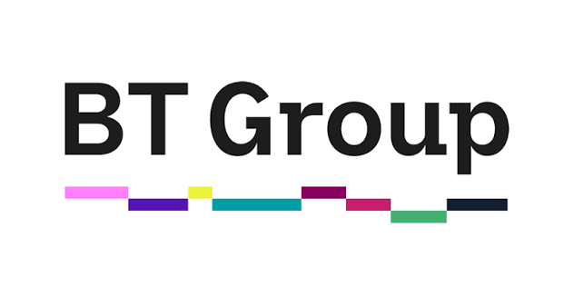
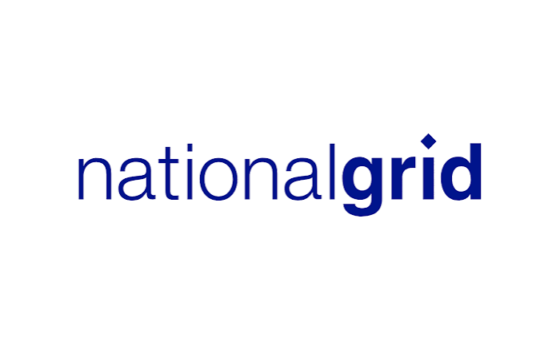



Featured organisations


Interested in Speaking?
Have a deployment story worth sharing? Join the NexGen Agentic AI Summit, London Edition, and tell a room of UK decision-makers what you built, what you learned and what the numbers showed.
We welcome practical, honest talks over product pitches: lessons from failure, regulatory navigation, technical design choices and measurable outcomes.
Button: Apply to Speak

Partners
[8+] International Sponsors

Become a Sponsor
Put your brand in front of the senior buyers shaping AI investment across the UK and Europe.
- Meet decision-makers: Reach CIOs, CTOs, risk leaders and heads of AI with live budgets and live problems.
- Show, don't tell: Demonstrate your platform on stage, at a stand or in a focused roundtable.
- Build credibility in the UK market: Associate your brand with a trusted, practitioner-led event.
- Hear the buyer's view: Learn what UK enterprises actually need from vendors on security, compliance and cost.
Button: Become a Sponsor

1-on-1 Meetings
Pre-arranged private meetings with senior leaders who are actively evaluating solutions. We match you with relevant delegates so every conversation counts.
Button: Enquire Now

Roundtable Discussions
Host a small, closed-door discussion on a topic you choose, such as agent governance, security or cost control. Lead the conversation, share your expertise and build relationships with the leaders who attend.
Button: Sponsor a Roundtable Discussion

